Nama : Achmad Eka Oktavianto

Nim : 4122007

**Instalasi Framework CI v.4**

**Kebutuhan Software**

* Xampp
* Vscod
* Composer
* Git Bash

**Composer**

* Lakukan instalasi (<https://www.google.com/url?q=https://getcomposer.org/Composer-Setup.exe&sa=D&source=apps-viewer-frontend&ust=1709007702711293&usg=AOvVaw0ZoN0JNXRHp7--j-lLiIY-&hl=en>)

**Cek hasil Instalasi**

* Buka git bash
* Ketik composer

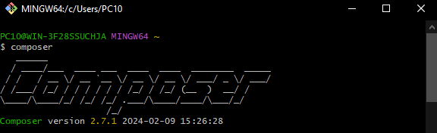

Jika muncul seperti diatas maka sudah selesai

* Ketik php –v

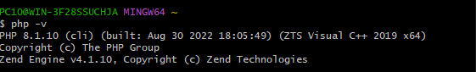

Jika muncul seperti diatas maka sudah selesai

**Install extension vcs**

* Buka visual studio code
* Klik ikon extension
* Ketik intelephense, dan prettier
* Disable php language

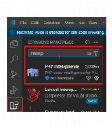

**Setting vsc**

* File > preference > setting
* Ketik format > centang format on save

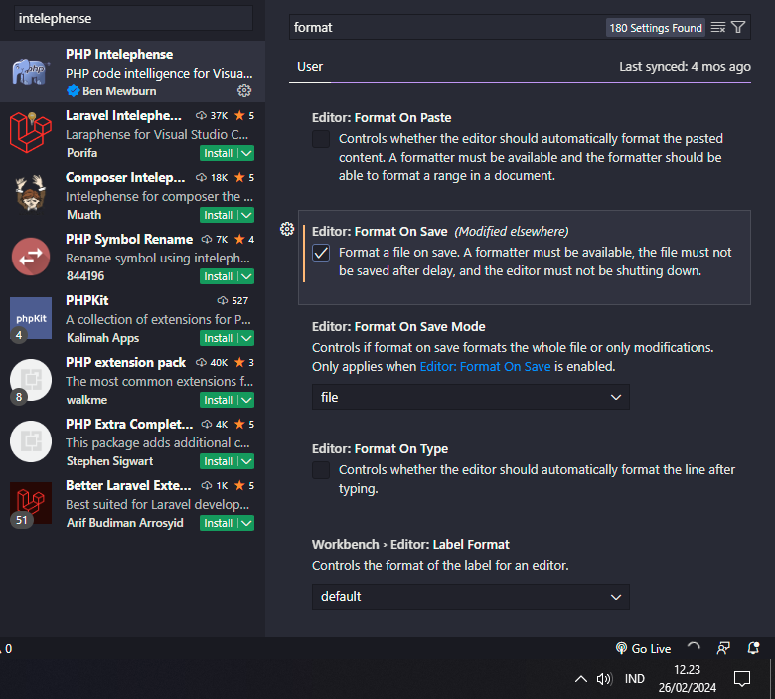

**Instalasi CodeIgniter 4**

* Buka folder xampp/htdocs
* Klik kanan > klik git bash
* Ketik “composer create-project codeigniter 4/appstarter poject-root”

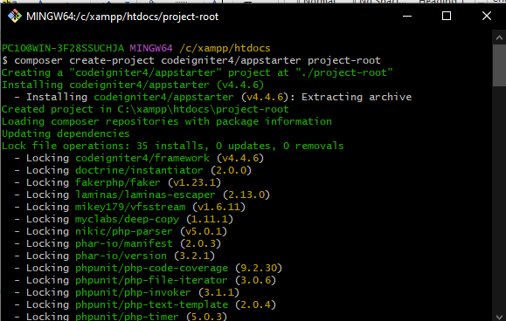

**Coba CodeIgniter 4**

* Buka git bash di folder xampp
* Ketik cd project-root (nama folder projek)
* Ketik php spark serve
* Buka browser dan ketik localhost:8080

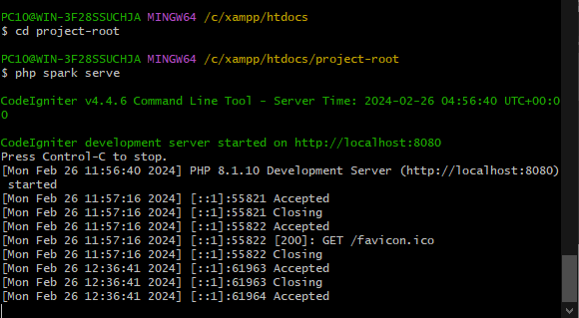

**Selamat datang di CI**

